DF/TO Expt - Fuels Sampling Protocol (2018)

Fuels: Brown’s Transect:
- 3 transects will be established at the plot corner representing each fuels treatment.
- Transect origins will be located away from plot corner and all transects will terminate at plot corner (Figure 1)

The tree plot corner will be the end of the transect. Transect origin will be marked with a pink pin flag. Total transect length will be 30 feet (slope uncorrected).
Measure/record the following:
- Transect ID
(Plot Name [B1, E2…]: Transect Direction [N, S, SE...] - > Plot Corner[NE, SE…])
- Slope (%) from Transect Origin to plot corner
- 6 feet for 1-hour fuels (tallies)
- 6 feet for 10-hour fuels
- 12 feet for 100-hour fuels
- 30 feet for 1,000-hour fuels (Sound and rotten)
- Duff Depth 6, 12, and 18 feet from origin (inches)
- Litter Depth 6, 12, and 18 feet from origin
- Fuel Depth 6, 12, and 18 feet from origin

Definitions for Fuels Transect Protocol (USDI National Park Service, 2003)
Litter – Includes freshly fallen leaves, needles, bark, flakes, fruits (e.g., acorns, cones), cone scales, dead matted grass, and a variety of miscellaneous vegetative parts. Does not include twigs and larger stems.

Duff – The fermentation and humus layers; does not include the freshly cast material in the litter layer. The top of the duff is where needles, leaves, fruits, and other castoff vegetative material have noticeably begun to decompose. Individual particles usually are bound together by fungal mycelia. The bottom of the duff is mineral soil.

Downed Woody Material – Dead twigs, branches, stems and boles of trees and shrubs that have fallen and lie on the ground.

Litter and Duff Measurement Rules (USDI National Park Service, 2003)
- At each sampling point, gently insert a trowel or knife into the ground until you hit mineral soil. Then carefully pull it away, exposing the litter/duff profile. Locate the boundary between the litter and duff layers. Vertically measure the litter and duff to the nearest 0.1 inch.
- Refill holes created by this measuring technique.
- Do not include twigs and larger stems in litter depth measurements.
- Occasionally moss, a tree trunk, stump, log, or large rock will occur at a litter or duff depth data collection point. If moss is present, measure the duff from the base of the green portion of the moss. If a tree, stump, or large rock is on the point, record the litter or duff depth as zero, even if there is litter or duff on top of the stump or rock.
- If a log is in the middle of the litter or duff measuring point, move the data collection point one foot over to the right, perpendicular to the sampling plane.

Tally Rules for Downed Woody Material (USDI National Park Service, 2003)
- Measure woody material first to avoid disturbing it and biasing your estimates.
- Do not count dead woody stems and branches still attached to standing shrubs and trees.
- Do not count twigs and branches when the intersection between the central axis of the particle and the sampling plane lies in the duff.
- If the sampling plane intersects the end of a piece, tally only if the central axis is crossed.
- Do not tally any particle having a central axis that coincides perfectly with the sampling plane.
- If the sampling plane intersects a curved piece more than once, tally each intersection.
- Tally uprooted stumps and roots not encased in dirt. Do not tally undisturbed stumps.
- For rotten logs that have fallen apart, visually construct a cylinder containing the rotten material and estimate its diameter.
- When stumps, logs, and trees occur at the point of measurement, offset one ft perpendicular to the right side of the sampling plane.
- Measure through rotten logs whose central axis is in the duff layer.

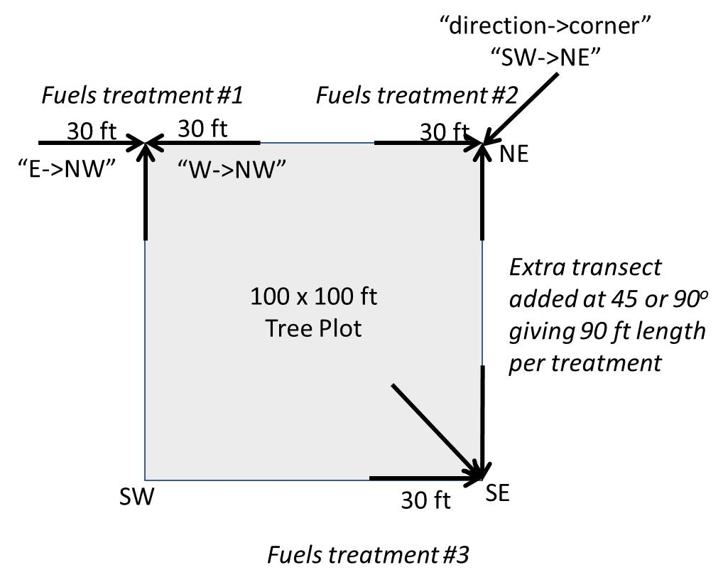

Figure 1. Brown’s Transect layout within plot. Two transects run along plot borders towards the corner. Third transect located at 45 or 90 degrees inside or outside plot where it best represents that fuels treatment. In this example, the SW corner does not have a fuels treatment sampled. Transects named by their direction towards their plot corner (direction->corner).

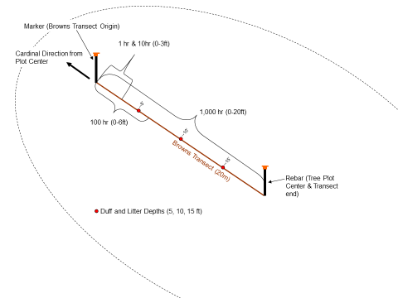
Figure 2. Brown’s Transect showing sub-sampling method

Discussion with Eamon Engber and Jason Teraoka: Eamon felt that 100 feet of 1000 hr sample total per plot would be needed. He was basing his idea from Whiskey-40 fuels sample, which was also a lop-and-scatter show and a similar fuel model. Eamon: it may take a little field recon to finalize the 1000-hr length, but if you re-visit Brown's 1974 guide, for heavy slash, the recommendation is 15-25 ft per transect, with the goal of avoiding "zero" tally's on any individual transects, and a total minimum of 35-50 1000-hr intersections for a sample area (stand). In other words, you might be able to get by with a 15 ft transect length for 1000-hr's, but you may have to confirm this in the field.

